Need help? Call us on 1-800 540-1472 and we can provide assistance or take a phone order.
NAME

DATE OF BIRTH

HOME ADDRESS |  | POSTAL CODE
DELIVERY ADDRESS
(IF DIFFERENT FROM ABOVE)
EMAIL ADDRESS

PHONE NUMBER

CREDIT CARD DETAILS (NAME, CARD NUMBER, EXPIRY, 3 OR 4 DIGIT CVV)

PROGRAM OR PRODUCT

CHOC, VANILLA OR STRAWBERRY SHAKES? (YOU CAN MIX AND MATCH)
FLAVOUR OF BARS (IF APPLICABLE)
SELECT PURCHASING OPTION (PREFERRED CUSTOMER ON AUTOSHIP IS RECOMMENDED) | 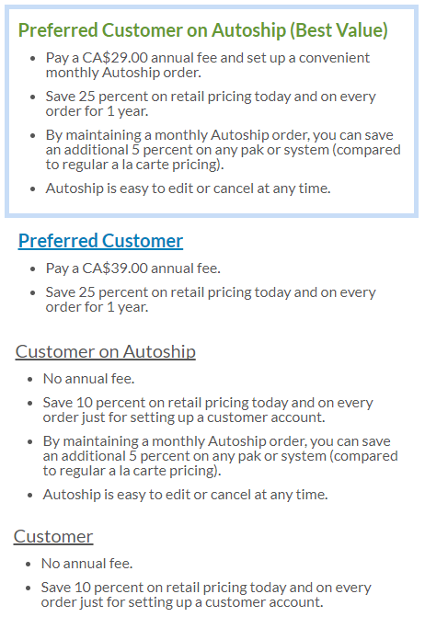
IF AUTOSHIP IS SELECTED, SPECIFY FIRST AUTOSHIP ORDER

